# **Section 19-1: Final Journey of The Buddha: Phase 1: Sāvatthi to Rājagaha**

This section focuses on the first phase of the Buddha's final journey. At around seventy-nine years of age, the Blessed One departed from Sāvatthi, traveling toward Rājagaha. However, Rājagaha was not his final destination—his journey would ultimately end in Kusinārā, in the Malla region where the final Parinibbana taken place. The final journey according to the scriptures and tradition is a very long one,[1] and in this first phase to reach Rājagaha the Blessed One and his sangha may have walked about 570 km (about 46 yojanas)[2] according to the present-day road map given below. [3]

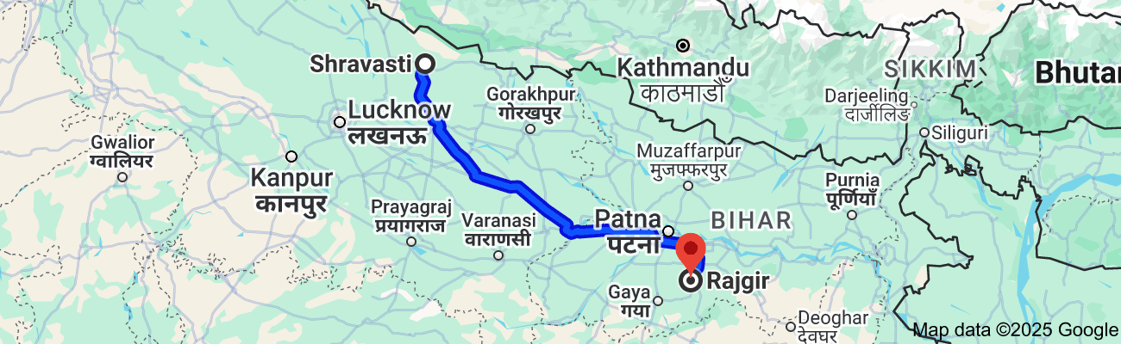

**First Phase of the Final Journey: Sāvatthi, to Rājagaha, Distance about 570 km (46 yojanas) [4]**

## **Departure from Sāvatthi**

According to tradition after completing his 44th rainy season (vassa) at the age of seventy-nine years in Sāvatthi (now Shravasti), the Buddha travelled his final journey to Rājagaha. The scriptures do not clearly describe how the journey from Sāvatthi began, so we must rely on tradition and other sources to bridge this gap.

*“ The Buddha observed regular Rains Retreats from the 21st to the 44th year at Jetavana and Pubbārāma monasteries at Sāvatthī, in the Kosala country, which served as his alms resort.*

*Then the Buddha spent his last Rains Retreat, the 45th in the village of Veḷuva, in Vesālī country, when on the verge of his Parinibbāna”[5]*

In Section 18, we saw that the Blessed One spent nearly twenty vassas in Sāvatthi, residing at times in Jetavana Monastery and at other times in Pubbārāma Monastery. In between, he travelled to various regions to spread the Dhamma for the welfare and benefit of many. During this period, his foremost lay supporter Anāthapiṇḍikapassed away, having made progress on the path (see Section 18). Among other prominent figures of that time who were ardent supporters of the Buddha —Queen Mallikā and King Pasenadi also died. The *Dhammachetiya Sutta* (MN: 89) records the final encounter of King Pasenadi with the Blessed One:

"*Again, Venerable Sir, the Blessed One is a noble, and I am a noble; the Blessed One is a Kosalan, and I am a Kosalan; the Blessed One is eighty years old, and I am eighty years old. Since that is so, I think it proper to offer such supreme honour to the Blessed One and to express such friendship."*

From this statement, we can infer that the Buddha was approximately 79 years old at the time (though the king said that he was 80 years!) Since he spent his final vassa—the 45th—in Vesāli, it suggests he was 80 at that point, having spent the 44th vassa at the age of 79 in Sāvatthi.

According to tradition, after completing his 44th rainy retreat at Jetavana Monastery, the Buddha, accompanied by a large number of bhikkhus, departed from Sāvatthi and began his journey toward Rājagaha. During the Buddha’s time, the rainy season retreat (*Vassa*) typically began on the Āsāḷha full moon day (June/July) and lasted three to four months, ending around the Kattika full moon day (October/November). Based on this timeline, we can assume that he left Sāvatthi around mid-November.

## The Possible Route from Sāvatthi to Rājagaha: The First Phase of the Buddha’s Final Journey

There is no definitive record in the Scriptures, Commentaries, or ancient maps detailing the precise route the Blessed One took when he left Sāvatthi for Rājagaha at the beginning of his final journey. However, to support this presentation and bridge the narrative between these two major events—his departure from Sāvatthi and his arrival in Rājagaha—we have constructed a plausible route. This reconstruction is based on geographical continuity, historical trade paths, proximity to rivers, and references to places the Buddha is known to have visited in various discourses—whether during this journey or earlier ones.

We acknowledge this proposed route is speculative and does not claim canonical authority. Its purpose is to offer a coherent and contextually supported narrative that helps visualize the first phase of the Buddha’s final journey from Sāvatthi to Rājagaha before continuing toward Kusinārā.

**The route proceeds as follows (see map below for reference):**

Possible Route:  
**Sāvatthi → Gonda → Sāketa → Sultanpur → Azamgarh → Ballia → Chapra → Ukkācalā → Pāṭaligāma → Rājagaha.**

### General Overview of the Route

From **Sāvatthi,** the path likely followed the River Aciravatī (now known as the Rapti) southward to **Gonda** (49 km), then further to **Sāketa** (Ayodhya), situated on the Ghaghara River. In ancient times, major roads often ran parallel to rivers, which provided water, fertile lands, and natural paths for travel. From Sāketa, the journey may have continued southeast along the Ghaghara to **Sultanpur** (possibly ancient Kusāvatī), then onward to **Azamgarh** (139 km from Sultanpur), and further to **Ballia** (111 km southeast)—the eastern boundary of Kosala and entry into Magadha.

From **Ballia,** the Blessed One and his monks may have reached **Chapra** (70 km east), located at the confluence of the Ghaghara and Ganges Rivers. Although we cannot determine precisely how the Sangha crossed the Ghaghara here, it is conceivable that during the dry season the river was shallow enough to wade across, especially at a narrow point (as suggested by modern sources [6]).

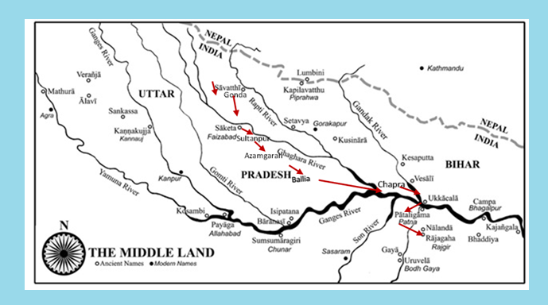

**Map1: The Final Journey of the Buddha: First Phase [7]**

From **Chapra**, the path likely continued east along the Ganges’ north bank, possibly crossing the Gandhak River to reach **Ukkācalā (**modern Hajipur). From there, they may have crossed the Ganges to arrive at **Pāṭaligāma** (modern Patna), and then proceeded to **Rājagaha**—completing the first leg of this long journey, spanning an estimated 570 km or more. Below is a more detailed look at the major points along this possible route:

### Sāvatthi – The Departure Point

Sāvatthi, situated on the west bank of the River Aciravatī (Rapti), [8] is mentioned frequently in the Pāli Canon (e.g., AN 6.62, AN 7.66, AN 8.19, AN 10.15). It was one of the principal cities where the Buddha resided and taught. From here, the Sangha may have begun traveling south along the riverbank.

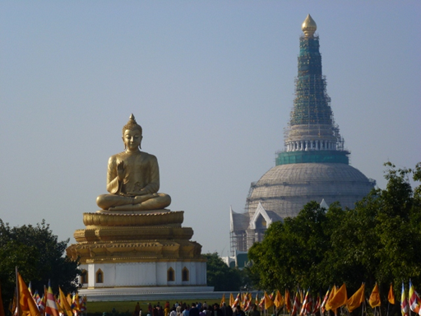

**Buddhist monument in Sāvatthi [9]**

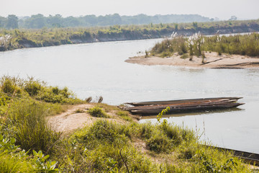

**Modern day picture of Rapti River (then River Aciravatī) [10]** (According to the Scriptures, the Buddha Often Walked Along the Banks of the River Aciravatī While Residing in Sāvatthī)

### Gonda – A Logical Stop

Gonda, about 49 km south of Sāvatthi, was historically part of Uttara Kosala and sits near a tributary of the Ghaghara River.[11] While no specific Buddhist sites have been identified in Gonda itself, its proximity to major centres of early Buddhism and its role as an agricultural and trade hub suggest it may have been part of the Buddha’s journey. Today, it retains spiritual relevance with both Buddhist and Hindu temples.

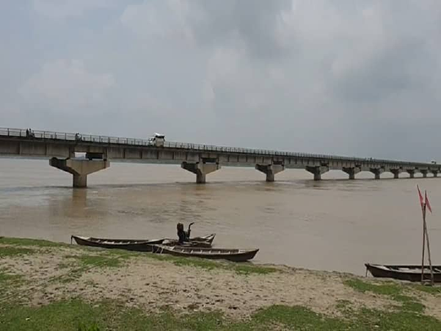

**Modern day picture of Ghaghara River-Bridge Crossing from the city of Gonda [12]**

### Sāketa (Ayodhya) – A City of Significance

About 50 km south of Gonda, Sāketa (modern Ayodhya) [13] was an important city during the Buddha’s lifetime. Situated on the southern bank of the Ghaghara River (also called Sarayu), it was a centre of both royal and merchant activity. [14]

The Buddha visited Sāketa several times, staying at Añjana Grove in the Deer Park (SN 48.43, SN 46.6). His disciples Sāriputta, Mahāmoggallāna, and Anuruddha also stayed in nearby groves (SN 52.4–6). The commentaries record that Visākhā’s parents moved here from Bhaddiya with royal permission, and her father, the wealthy merchant Dhanañjaya, played a key role in the city’s prosperity (see Section 18).

Strategically located at the intersection of major trade routes—north-south (Sāvatthi–Pratiṣṭhāna) and east-west (Rājagaha–Vārāṇasī–Sāvatthi–Takṣaśilā)—Sāketa likely had the infrastructure and devotion to welcome the Buddha and the Sangha during their travels.

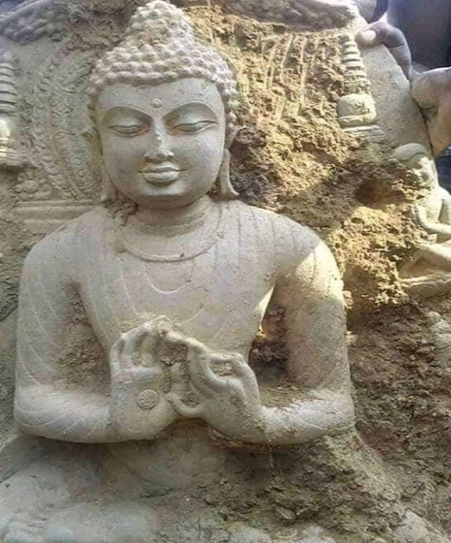

**Statue of a Buddha excavated in Ayodhya [15]**

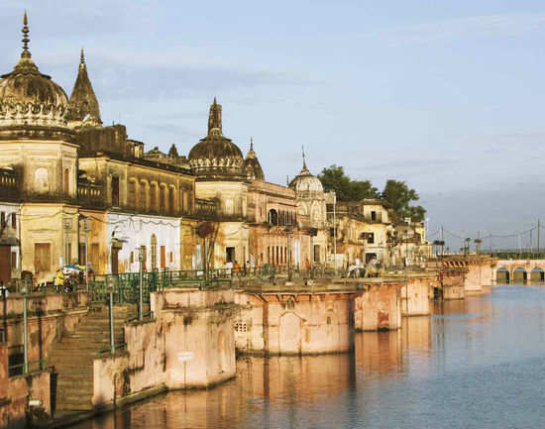

**Modern day picture of Ayodhya located on the banks of the Saryu River [16]**

### Dhamma delivered at Sāketa

Though not explicitly linked to the Blessed One’s final journey, a few profound discourses given at Sāketa beautifully illustrates his presence there. We have presented the following:

Five spiritual faculties and their transformation into the five powers

While residing in the Añjana Grove in the Deer Park, the Buddha taught the bhikkhus about the five spiritual faculties and their transformation into the five powers.[17]

Faith, energy, mindfulness, concentration, and wisdom—these qualities, when developed, serve both as faculties that guide and as powers that protect. The Buddha emphasized that there is no real difference between them; they are like a river flowing around an island—seen as one stream or two, depending on the perspective. The essence remains the same.

Through steadfast cultivation of these five strengths, a noble disciple is capable of breaking the bonds of ignorance and attaining liberation—right here, in this very life.

Faith becomes a power when it is unwavering.  
Energy becomes a power when it is tireless.  
Mindfulness becomes a power when it is steady.  
Samadhi becomes a power when it is undisturbed.  
Wisdom becomes a power when it sees clearly and deeply.

This inspiring teaching reminds us: the path is not far. It begins with trust, effort, awareness, clarity, and insight—unshaken, unwavering, and luminous.

#### What leads to true knowledge and liberation

One day, while the Blessed One was residing in the Deer Park at Añjana Grove in Sāketa, the wanderer Kuṇḍaliya approached, exchanged greetings, and asked: [18]

"Master Gotama, I see ascetics debating to defend their views. But for what benefit does the Tathāgata live?"

"**The Tathāgata lives for the benefit of true knowledge and liberation**," the Blessed One replied.

Kuṇḍaliya then inquired what leads to true knowledge and liberation. The Buddha explained that the seven factors of enlightenment, cultivated, bring about true knowledge and liberation. These factors are fulfilled through the four establishments of mindfulness, which arise from the three kinds of good conduct—bodily, verbal, and mental. Good conduct, in turn, depends on restraint of the senses, which is achieved when a bhikkhu remains unattached to pleasant and unpleasant sensory experiences, free from longing and ill will.

The Buddha further explained how each step nourishes the next: mindfulness develops the factors of enlightenment, which lead to liberation. Upon hearing this, Kuṇḍaliya was deeply moved and declared:

"Magnificent, Master Gotama! You have illuminated the Dhamma as one who sets upright what was overturned, reveals what was hidden, and holds up a lamp for those in darkness. From today, I go for refuge to the Buddha, the Dhamma, and the Saṅgha for life."

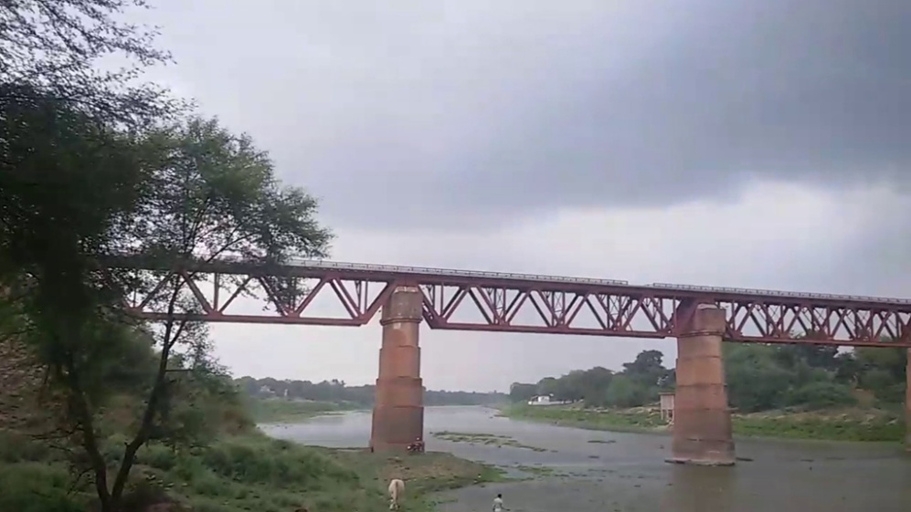

**Modern day picture of Gomti River-Bridge Crossing from the city of Sultanpur [19]**

### Sultanpur (Kushavatī)—An Ancient Location

Located on the banks of the Gomti River (also known as Gumti), a tributary of the Ganges, Sultanpur in present-day Uttar Pradesh could have been another possible stop on the Buddha’s southward journey from Ayodhya. It lies approximately 65 km south of Ayodhya. In ancient times, the region now called Sultanpur was known by names such as Kushbhawanpur, Kushapura, and Kushavatī. [20]

Although Sultanpur does not hold the same prominence as major Buddhist sites like Sarnath or Kusinārā, archaeological remains at Mahmoodpur—a village about 8 km northwest of the city—indicate a historical Buddhist presence. [21] These findings, along with the presence of several modern-day Buddhist temples alongside a majority of Hindu shrines, reflect the area's enduring spiritual significance and suggest it may have been on or near a route frequented by early followers of the Dhamma.

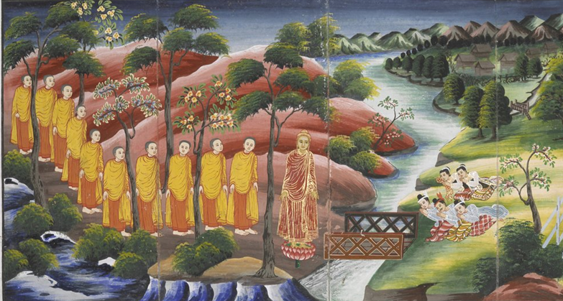

**The Buddha and the Sangha crossing a river on their journey towards east [22]**

### Azamgarh—a Location of Ancient Kosala Kingdom

Continuing southeast along the banks of the Ghāghara River from Sultanpur, the next major stop on this possible route is **Azamgarh.** Located approximately 139 km southeast of Sultanpur, Azamgarh lies on the Tamsa River and historically formed part of the ancient Kosala Kingdom. Only its northeastern regions were under the rule of the Mallā during the Buddha’s time. [23]

While Azamgarh itself is not known for prominent ancient Buddhist monuments, its proximity to Sarnath—a key pilgrimage site—suggests it lay within a region of strong Buddhist influence. The presence of several contemporary Buddhist temples in and around Azamgarh may echo its ancient connection to the spread of the Buddha's teachings, particularly as Kosala was one of the central regions that supported the Dhamma during the Buddha’s lifetime.

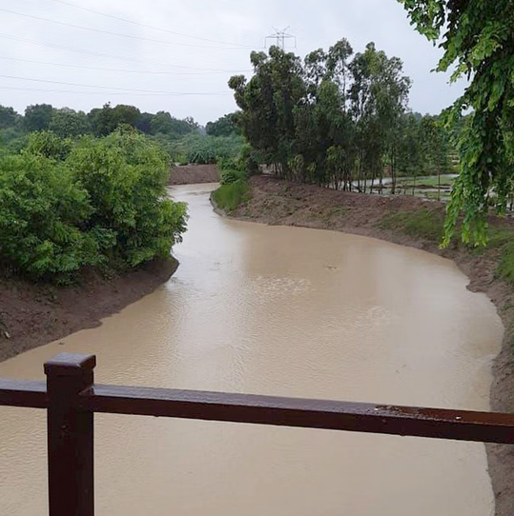

**Tamsa River near Azamgarh[24]**

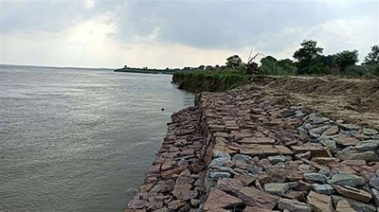

**River Ganges near Ballia [25]**

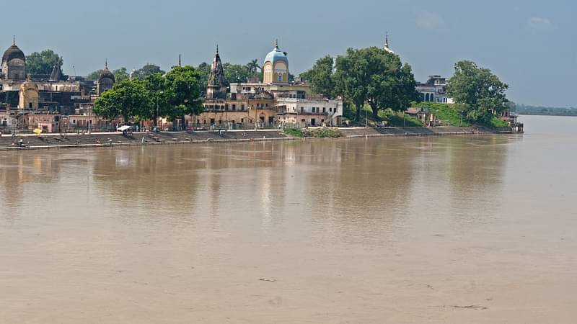

**River Saryu (Ghāghara River) in Ballia** **[26]**

### Ballia—Junction of highway from Sarnath to Kusinārā

Traveling further southeast from Azamgarh, still following the Ghāghara River, the next notable location is **Ballia**, situated near the confluence of the Ganges and Ghāghara rivers in the northeastern most part of Uttar Pradesh, close to the Bihar border. Ballia lies about 139 km southeast of Azamgarh.

The ancient name of Ballia is believed to derive from the sage Vālmīki, the revered author of the *Rāmāyaṇa*, who is said to have lived or established a hermitage in the area. [27]

Though not a major Buddhist site today, Ballia lies along the route of the "**Dhamma Carikā"**—a pilgrimage circuit that stretches from Sarnath to Kusinārā and is thought to pass through this region. [28] The presence of several Buddhist temples in Ballia today may indicate that followers of the Buddha once lived here, especially considering its historical ties to Kosala and Magadha, both of which were strongholds of early Buddhism.

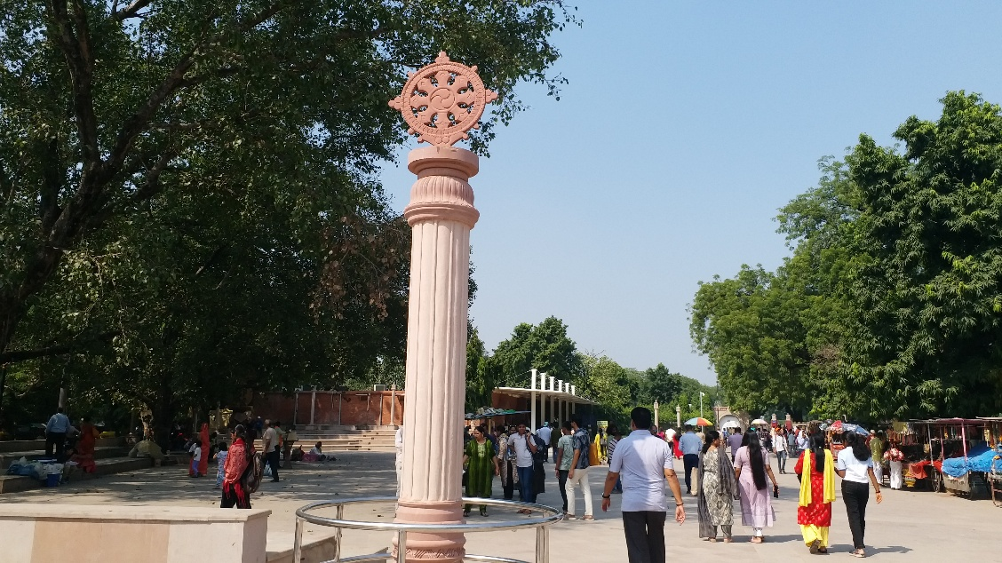

**Padayatra from Sarnath to Kushinagar via Ballia [29]**

**Note:** Around 5000 devotees to participate: In-charge of Sarnath Dhamma Learning Centre, monk Chandima Thore said Sarnath was Lord Buddha's the preaching site while Kushinagar was place of Mahaparinirvana. Thus, Dhamma Charika will be organised between these two holy places. It will depart Sarnath temple with around 5000 devotees and cover about 500 kilometres to Kushinagar, where the yatra would be concluded.[30]

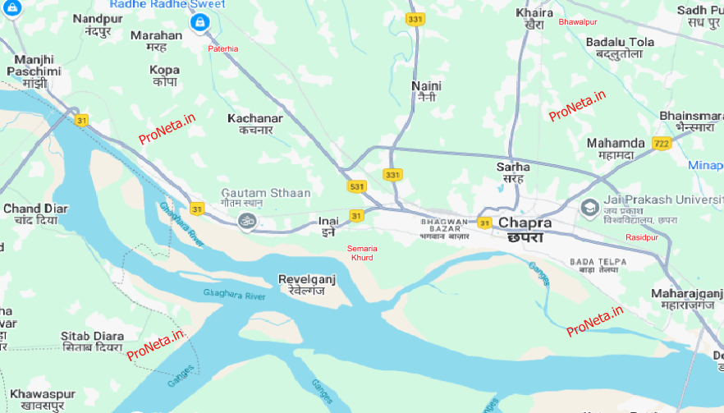

**Location of Chapra at the junction of Ghaghara River merging to Ganges River [31]**

### Chhapra—A Palce of Refuge

From Ballia, the route continues eastward to the city of Chhapra (also spelled Chapra), located about 108 km away in western Bihar. Chhapra lies near the confluence of the Ghāghara and Ganges rivers, a location that has historically made it an important river port and trading centre from ancient times to the present. The region was traditionally known as **Sāraṇa**, a name often interpreted as meaning “asylum” or “refuge.” [32]  Today, Chhapra serves as the administrative centre of the Saran district, a region with deep cultural and historical roots.

Although there are no widely recognized ancient Buddhist monuments within Chhapra itself, the surrounding region has rich associations with Buddhism. For example, nearby Chirand—just 10 km east of Chhapra—is an important archaeological site. Excavations there have revealed continuous human habitation from the Neolithic period (around 2500 BCE) through the Chalcolithic and Iron Age, up to around 30 CE. [33]

Chhapra is also home to a sacred site called ‘Gautam Sthān’—“Place of Gotama”—though this is not a Buddhist site. [34]. Nevertheless, its name evokes the memory of the Buddha and suggests that the area may have preserved traces of his legacy. Given Chhapra’s location between key Buddhist centres such as Pātaligāma (modern Patna) and Bodhgayā, and its position along important trade and travel routes, it is plausible that the Buddha passed through or near this area during his final journey, continuing to share the Dhamma for the benefit of the many.

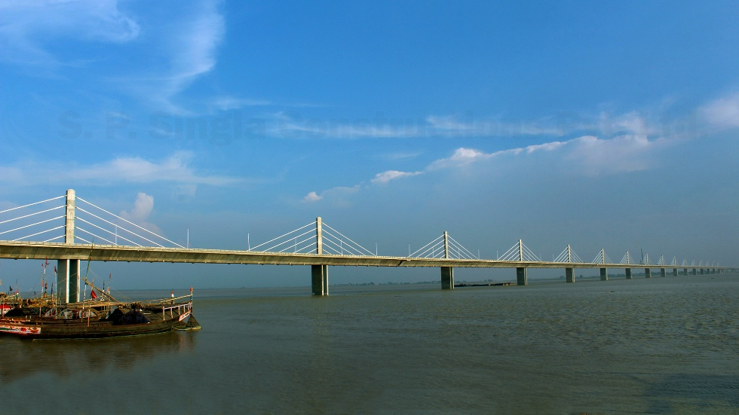

**India’s longest multi-span Extradosed Bridge, 4.35 Km -across the Ganges connecting Ara-Chhapra in Bhojpur, Bihar[35]**

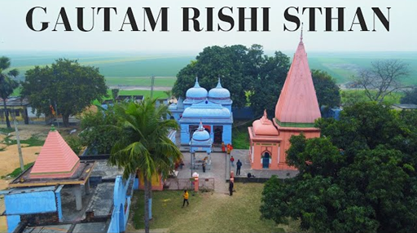

**Gautam Sthan at Revelganj is situated on the bank of the holy river Saryu or Ghaghara 8 kilometres west of Chapra, Bihar, India.[36]**

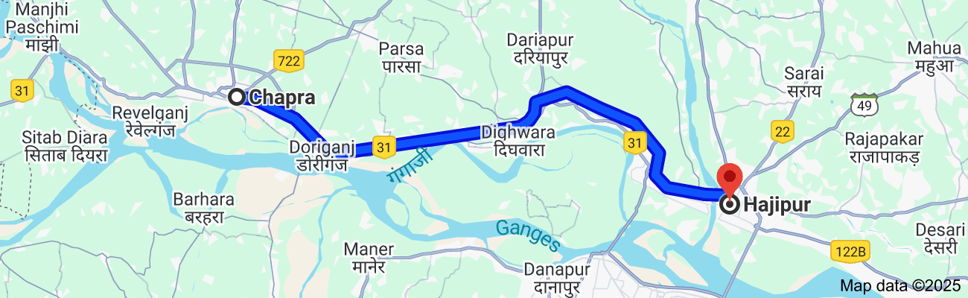

**Present day road map from Chapra, Bihar to Hajipur in Bihar (about 57 km) [37]**

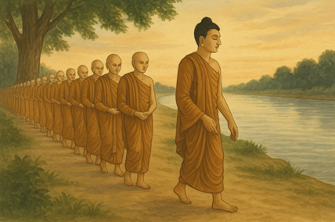

**The Buddha walking with large number of Bhiikhus along the River Ganges: From Saran to Ukkacala 57 km (4.6 Yojanas) [38]**

### Ukkacala (Hajipur) —Key Crossing Point of Ganges

From Chapra, the Blessed One and his Sangha may have journeyed eastward along the serene northern bank of the Ganges River, covering approximately 57 kilometres (about 4.6 yojanas), likely progressing at the customary pace of one yojana per day. Eventually, they reached Ukkacala, an ancient locality within the territory of Vesali, now identified with modern-day Hajipur in the state of Bihar.

Ukkacala, situated as the first settlement on the northern bank of the Ganges, has historically served as a key crossing point to reach Patna (ancient Pataligama). This crossing was significant both during the time of the Buddha and continues to be so in modern times.

Today, Hajipur and the greater Vaishali region remain important pilgrimage sites for Buddhists, home to sacred landmarks such as the Buddha Relic Stupa, the Vishwa Shanti Stupa, and the Ashoka Pillar. Some sources also suggest that a portion of Venerable Ananda’s relics may have been enshrined in Hajipur, [39] though this has not yet been confirmed by archaeological evidence. [40]

It is likely that the Blessed One and the Sangha rested at Ukkacala after their long journey, offering spiritual guidance to the devoted communities there.

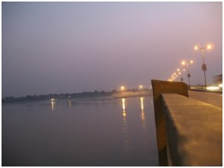

**Hajipur Town along the Ganges River [41]**

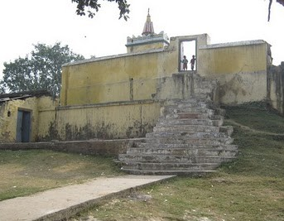

**The Ramchaura Mandir on top of the Aananda Stupa, Hajipur, Bihar, India. The photo is taken looking south east[42]**

### Dhamma Given in Ukkacelā

The following of a summary of a discourse given by the Buddha sitting along on the bank of Ganges River near ancient Ukkacelā village.

#### The Parable of the Cowherd – A Teaching at Ukkacelā

While dwelling on the banks of the Ganges at Ukkacelā in the Vajjian country, the Blessed One shared a powerful parable with the bhikkhus. The spoke of two cowherds—one foolish and one wise.[43]

The **foolish cowherd**, without examining the riverbanks or looking for a safe crossing, led his cattle into deep waters where they perished. This, the Buddha explained, is like those recluses and brahmins who are unskilled in understanding this world and the next, the realm of Māra and what lies beyond death. Following such teachers leads to confusion and harm.

In contrast, the **wise cowherd**, after carefully surveying both shores, led his herd across a safe ford. He guided the strong bulls first, followed by the others in order of strength, until even the weakest calf, urged by its mother, safely reached the far shore. This, said the Blessed One, is like the Noble Ones—those fully awakened, those on the path, and those with faith—each progressing toward the further shore of liberation according to their spiritual maturity.

The Buddha concluded:

“*Just as the wise cowherd brought all to safety, so too, one who is skilled in the world and the Dhamma leads others toward the deathless. Those who place faith in such a guide walk the path to lasting welfare and peace”*

### References to Ukkacelā in the Scriptures

The existence of **Ukkacelā** in ancient India is mentioned multiple times in Buddhist texts:

* **MN45**(**Cūḷagopālaka Sutta) :** As mentioned above.
* **SN39:1 (Nibbāna Sutta)**: On one occasion the Venerable Sāriputta was dwelling among the Vajjians at Ukkacelā delivered this sutta to wanderer Sāmaṇḍaka.
* **SN47:14** **(Ukkacelā Sutta)** On one occasion the Blessed One was dwelling among the Vajjians at Ukkacelā on the bank of the river Ganges, together with a great Bhikkhu Saṅgha, not long after Sāriputta and Moggallāna had attained final Nibbāna, he delivered this sutta.

(**Note:** we will discuss this occasion in detail in the next section (19-2) of the final journey)

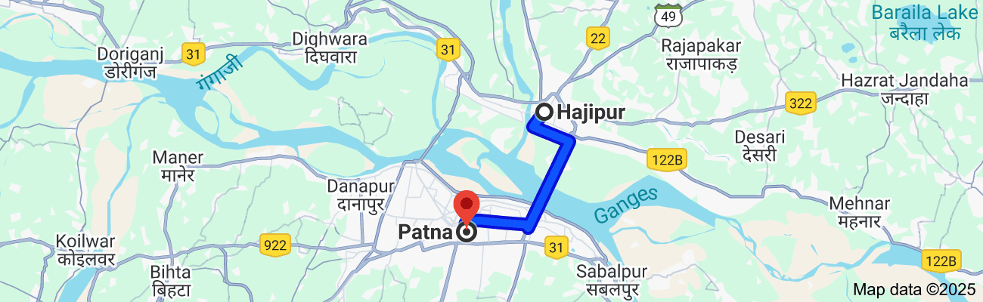

**Modern day map showing the distance from Hajipur to Patna about 21 km**

Crossing the Mighty Ganges River  
After resting on the banks of the Ganges at the village of Ukkacelā, the Buddha and the Sangha likely continued on their journey to the next destination along the suggested route—**Pataligama** (modern-day Patna in Bihar). Since there were no bridges at the time, they may have crossed the river at this point with the assistance of local villagers using ferry boats. The Ganges here is notably wide—spanning approximately 5 to 6 kilometres—and quite deep. [44] As mentioned earlier in Section 14-3, the Buddha and a large group of monks had previously crossed this great river using the royal yachts of King Bimbisāra during their journey to Vesālī.

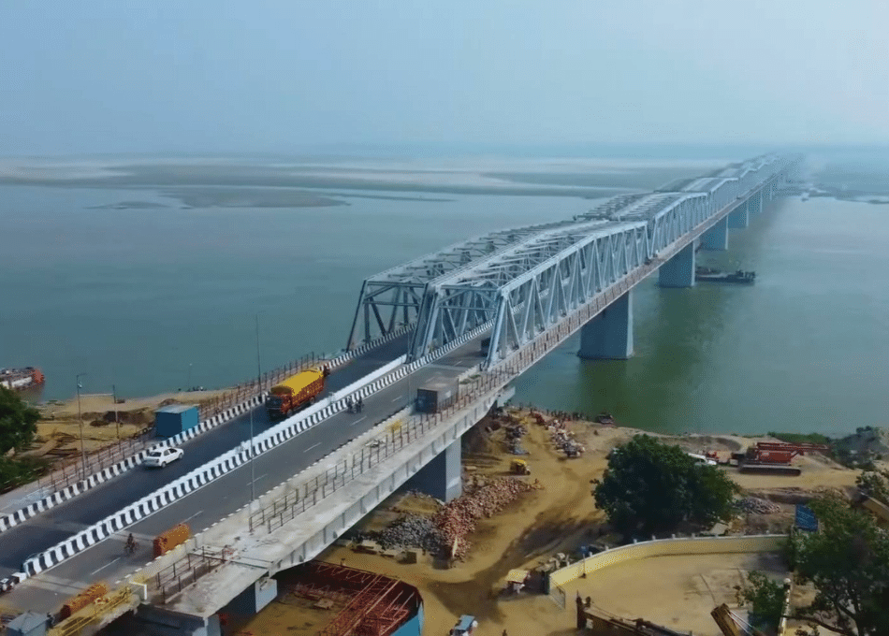

**Present day crossing the Mighty Ganges River from Hajipiur to Patna by the Mahatma Gandhi Setu Bridge (length about 5.5 km) [45]**

## Arriving at Pāṭaligāma—An Ancient Capital

Having crossed the serene waters of the River Gaṅgā, the Blessed One—accompanied by the venerable Sangha—arrived at *Pāṭaligāma*, a village resting peacefully on the river’s southern bank. This was no ordinary village. The scriptures speak of a place graced by the presence of many devoted lay disciples who held the Dhamma close to their hearts. In such an environment, filled with faith and reverence, it is only natural to imagine the Blessed One being received with offerings, humility, and heartfelt joy.

It is likely that the Buddha and his disciples paused here, resting amidst the warmth of the community—perhaps under the shade of trees or within humble dwellings offered by faithful householders. Their presence would have sanctified the land, turning the simple village into a sacred space of refuge and inspiration.

This moment in Pāṭaligāma marks not just a stop along the Buddha’s final journey, but also a quiet affirmation of how deeply the Dhamma had taken root in the hearts of the people. From here, the journey would continue toward Rājagaha, but the memory of the Buddha’s presence in this village would live on in the collective devotion of generations to come.

Pataligama (modern Patna in Bihar) located in the banks of mighty Ganges during the time of the Buddha was a successful river port bringing much revenue to the Magadha kingdom. It was on the high road of Kusinara the city of Malla Kingdom and Rājagaha capital of Maghdha Kingdom. The Buddha predicated that this palace in future will be a prosperous and a great city. [46]

*“ Ānanda, as far as the Ariyan realm extends, as far as its trade extends, this will be the chief city, Pāṭaliputta, scattering its seeds far and wide”*

Eventually, when King Asoka established the Mauryan Empire, *Pataligama*—which came to be known as *Pataliputta*—became the capital of the Magadha Kingdom. It flourished as a significant centre of trade and culture.

Although Patna today may not possess the same abundance of prominent Buddhist sites as nearby places like Bodh Gaya or Rajgir, its historical connection to Buddhism remains profound. As the heart of the Mauryan Empire and the site of the Third Buddhist Council, Patna holds an essential place in the Buddhist narrative.

Many of its ancient sites have not been properly excavated, which is why specific Buddhist landmarks are limited. Nevertheless, in and around the city, there are several places dedicated to Buddhism. Notably, Patna houses a significant museum that features a collection of Buddhist sculptures and a terracotta urn believed to contain the relics of the Buddha. The city also accommodates numerous Buddhist temples, harmoniously coexisting with Hindu and Jain places of worship.

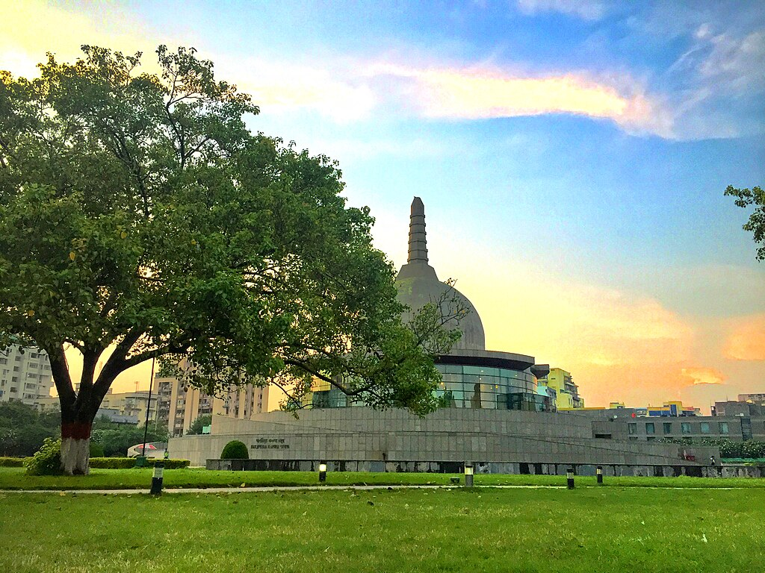

**Buddha Memorial Park in Patna: Patliputra Karuna Stupa in Buddha Smriti Park [47]**

### References to Pataligama or Patliputra in the Scriptures

The existence of *Pāṭaligāma*—later known as *Pāṭaliputta*—is attested multiple times in the Pāli Canon, underscoring its significance in the Buddhist tradition. These references appear across various suttas and Vinaya texts, reflecting both the presence of the Blessed One and the activities of the Sangha in this important city:

1. **DN 16 – Mahāparinibbāna Sutta**: This discourse records several encounters of the Buddha and the Sangha in Pāṭaligāma. Some of these key events will be discussed in Section 19-2 of our work.
2. **MN 52 – Aṭṭhakanāgara Sutta**: This sutta recounts how the householder Dasama of Aṭṭhakanāgara invited bhikkhus from both Pāṭaliputta and Vesālī. He generously offered them food, robes, and lodging. The Sangha on this occasion was led by the Venerable Ānanda. This event took place after the Blessed One's Parinibbāna.
3. **MN 94 – Ghoṭamukha Sutta**: This discourse describes Venerable Udena’s conversation with the Brahmin Ghoṭamukha, who had constructed an assembly hall in Pāṭaliputta for the Sangha. It later became known as the Ghoṭamukha Hall. This event too occurred after the Buddha’s passing away.
4. **Vinaya Piṭaka – Cīvarakkhandhaka (Kd 8)**: Mentions senior bhikkhus—including Venerables Nīlavāsī, Sāṇavāsī, Gotaka, Bhagu, and Phaḷikasantāna—residing in Pāṭaliputta at the Kukkuṭārāma Monastery.
5. **Vinaya Piṭaka – Bhesajjakkhandhaka (Kd 6)**: Refers to the officials Sunidha and Vassakāra, ministers of King Ajātasattu of Magadha, who were engaged in constructing a fortress at Pāṭaligāma to protect against the Vajjians.
6. **AN 5.50 – Nārada Sutta**: Describes Venerable Nārada residing in Pāṭaliputta, at the Cock’s Park (*Kukkuṭārāma*), and his notable encounter with King Muṇḍa.
7. **Theragāthā 3:235**: Mentions that Venerable Khujjasobhita was dwelling in Pāṭaliputta.
8. **Udāna 8.6**: Records a discourse delivered by the Buddha to the villagers of Pāṭaligāma, reflecting His compassion and direct engagement with lay communities.
9. **Therīgāthā 15:402**: Refers to two bhikkhunīs from the Sakyan clan—Isidāsī and Bodhī—who lived in Pāṭaliputta, indicating the presence of an active community of nuns in the city.

These references collectively attest to Pāṭaligāma/Pāṭaliputta's vital role as a hub of Buddhist activity during and after the time of the Blessed One.

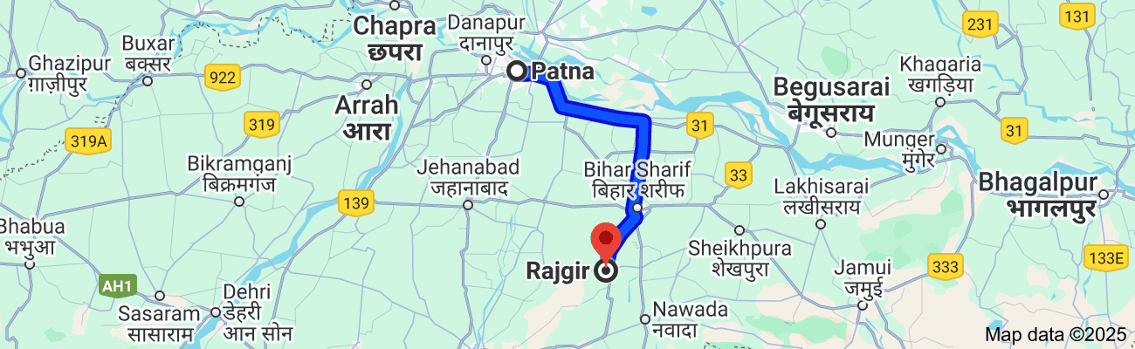  
**Distance from Patna to Rajgir according to modern day map is about 104 km (about 8 yojanas) [48]**

## **Walking Towards Rājagaha — The Path that Points the Right Way**

From *Pāṭaligāma* to *Rājagaha* stretches a journey of roughly eight yojanas—a path walked not merely with footsteps, but with mindfulness and quiet determination. If we imagine the Blessed One and the noble Sangha walking gently at a steady pace of one yojana per day, the journey would have taken about eight or nine days, winding through the heart of Magadha, with each step echoing the rhythms of a life lived in harmony with Dhamma.

The scriptures are largely silent about this specific episode—the return of the Blessed One to Rājagaha after a long absence. As earlier noted, (in Section 18), the Buddha had spent nearly twenty vassas in and around Sāvatthī, and there is no recorded mention of him visiting Rājagaha during that period. The 17th vassa, spent in Magadha, seems to be the last known rainy season near Rājagaha before the final vassa (the 45th) at Vesālī.

Yet, in this silence, we sense a deeper movement: the Buddha walking steadily back toward the city where his early ministry had once flourished—where kings, ministers, householders, and recluses had once gathered to hear the Dhamma. The path to Rājagaha was not just a return to a city, but perhaps, a compassionate return to hearts in need of healing.

In the Sāmaññaphala Sutta (DN: 2), we encounter a poignant moment. The Blessed One is staying at the Mango Grove of *Jīvaka Komārabhacca*, just outside Rājagaha. It is here that King *Ajātasattu*, the son of the late King Bimbisāra, comes to meet him—accompanied by his royal entourage and the devoted physician Jīvaka.

The king, not recognizing the Buddha, asks quietly, *“Where is the Lord?”*  
And Jīvaka, with reverence, replies, *“That is the Lord, Sire—seated there against the central pillar, surrounded by the noble Sangha.”*

This was not merely a royal visit. It was a return of conscience, a moment of reckoning. Ajātasattu, once misled by the evil counsel of Venerable Devadatta, had committed grievous acts, including the murder of his own father. And yet, here he was—seeking wisdom, forgiveness, and perhaps, redemption.

With infinite compassion, the Blessed One does not condemn him, but gently leads him to a truth that shines like a beacon through the fog of delusion. In response to the king’s question about whether there is any tangible fruit of the renunciate life, the Buddha unfolds a teaching that starts with the transformation of a slave into a recluse—one who, through self-restraint and virtue, becomes worthy of honour from even the highest in society.

And then, with sublime patience, the Buddha continues to reveal the higher fruits of the homeless life: peace, contentment, meditative joy, and ultimately, the supreme fruit—Nibbāna, the end of all suffering.

So powerful was this discourse that the king, deeply moved, declared himself a lay follower of the Buddha, the Dhamma, and the Sangha. In a moment of honest self-reflection, he confessed:

*“Lord, transgression overcame me… in that I, for the sake of the throne, deprived my father, that good man and just king, of his life. May the Blessed One accept my confession, that I may restrain myself in the future.”*

The Buddha accepted his confession, affirming a profound truth:

*“He who acknowledges his transgression as such and confesses it for betterment in future, will grow in the Ariyan discipline.”*

Yet, the Buddha later told the monks that had it not been for that unwholesome act of patricide, King Ajātasattu would have attained Stream-entry, opening the Dhamma-eye then and there.

### A Living Lesson from the Path

This deeply moving episode reveals something timeless: the Dhamma always points the right way. Even amidst past wrongdoings, confusion, and sorrow, the Dhamma offers a path forward—a way of truth, transformation, and liberation. Where greed, hatred, and delusion lie in wait to trap us, the Dhamma teaches restraint, clarity, and compassion.

The Blessed One did not force his truth upon anyone. He waited until the time was ripe, until the heart of a once-deluded king turned toward light—and then, with great kindness, he opened the way.

This is the nature of the Dhamma. It does not punish—it purifies. It does not judge—it guides. And no matter how far one has strayed, as long as there is sincerity and a turning of the heart, the Dhamma is always ready to lead us gently home.

Therefore, dear reader, walk with the same gentle footsteps that many devotees once followed the Blessed One—each word of Dhamma you reflect, each reflection you share with the fellow beings is like offering a fragrant lotus at the feet of the Buddha.

With this reflection, we conclude this section. The next section (19-2) will focus on the events that unfolded in Rājagaha during the Buddha’s final visit to that ancient capital of Magadha Kingdom.

**End Notes: Section 19-1**

1. According to Mahaparinibbana sutta: DN:16.
2. Source: https://www.unitsmash.com/converters/length/kilometer/to/yojana/570
3. Google map
4. Ibid.
5. Source: The Great Chronicles of the Buddhas by Mingun Sayādaw: revised and re-edited by  
   Ānandajoti Bhikkhu: https://ancient-buddhist-texts.net/English-Texts/Great-Chronicles/index.htm
6. Source: <https://en.wikipedia.org/wiki/West_Rapti_River>
7. Route indicated on the Map by : https://wiswo.org/books/footprints/
8. Source: <https://en.wikipedia.org/wiki/West_Rapti_River>
9. Source: https://en.wikipedia.org/wiki/Shravasti
10. Source: https://stock.adobe.com/search/images?k=%22rapti%20river%22
11. Gonda, city is located in east-central [Uttar Pradesh](https://www.britannica.com/place/Uttar-Pradesh) state, northern [India](https://www.britannica.com/place/India). It lies about 60 miles (95 km) northeast of [Lucknow](https://www.britannica.com/place/Lucknow), on a tributary of the [Ghaghara River](https://www.britannica.com/place/Ghaghara-River).
12. Source: ABP Newes: https://www.abplive.com/states/up-uk/gonda-news-ghaghra-river-
13. Source: The ancient name of Ayodhya was Sāketa in Kosala. It is a sacred place both for Buddhist and Jainas. The legendary Rāmayana also stated Ayodhya was the birthplace of Rāma though no historical record is found. Sāketa is recorded in Chinese, Greek, Sanskrit, and Buddhist sources. https://ariyajoti.wordpress.com/2020/05/25/saketa-an-ancient-buddhist-site/
14. South of Sāvatthī, by a direct and reasonably straight road, was Sāketa, for more information see: https://wiswo.org/books/footprints/
15. Source: https://ariyajoti.wordpress.com/2020/05/25/saketa-an-ancient-buddhist-site/
16. Source: https://timesofindia.indiatimes.com/travel/ayodhya/ayodhya/ps48100510.cms
17. SN48:43.
18. SN46:6
19. Source: https://www.youtube.com/watch?v=FX14c4y7bKg
20. Source: https://sultanpur.dcourts.gov.in/about-department/history/#:~:text=The%20city%20of%20Kusbhawanpur%20was,on%20the%20site%2C%20called%20Sultanpur.
21. Remnants of a Buddhist monastery, for more information see: Wikipedia.
22. Source: https://www.meisterdrucke.uk/fine-art-prints/Burmese-School/1354767/Monks-Crossing-a-River,-Scenes-from-the-Life-of-Buddha.html
23. Source: https://azamgarh.nic.in/history/
24. Source: https://www.amarujala.com/uttar-pradesh/faizabad/tamsa-river-on-rise-faizabad-news-lko4699649118
25. Source: https://en.wikipedia.org/wiki/Ballia_district
26. Source: Deccan Herald: https://www.deccanherald.com/india/uttar-pradesh/flooding-in-saryu-river
27. Source: https://en.wikipedia.org/wiki/Ballia#:~:text=The%20name%20Ballia%20is%20an,%22%20(balu%20meaning%20sand).
28. Source: https://www.etvbharat.com/en/!state/devotees-to-hold-dhamma-charika-to-spread-message-of-peace-and-harmony-enn24110401793
29. Ibid.
30. Ibid.
31. Source: https://proneta.in/chapra_assembly_constituency_bihar-118/
32. Source: https://en.wikipedia.org/wiki/Chhapra
33. Source: https://en.wikipedia.org/wiki/Saran_district#:~:text=History,-Historical%20population&text=Pop.,%C2%B1%25%20p.a.&text=source:,was%20released%20in%20September%202016.
34. Gautam Asthan is the ashram of the Gautam Rishi and lies 5 km of Chapra.  
    Read more at: <https://www.nativeplanet.com/saran/attractions/gautam-asthan/#overview>
35. Source: https://spsingla.com/?projects=4-35-km-long-4-lane-h-l-bridge-with-approach-road-across-river-ganga-including-1920m-long-extradosed-bridge-connecting-ara-chhapra-in-bhojpur-bihar
36. Source: https://www.youtube.com/watch?v=KZu-9sUh2Tg
37. Google map
38. AI generated image.
39. Later tradition says that after Ānanda died, his ashes were shared between Magadha and the Licchavis. The remains of the stupa built by the Licchavis at Ukkācalā can be found in the Rambhadra district of Hajjipur. Source: ttps://wiswo.org/books/footprints/
40. Source: <https://www.buddhanet.net/e-learning/pilgrim/pg_08/> * it says that after passing away of Venerable Ananda his ashes were deposited in two stupas: one bult by King Ajasath on the south river bank of Ganges River in then Magadha Kingdom and the other stupa at north bank of the river by Licchavi Princes of Vesali. The south bank stupa has been washed away but the north bank one is It is now a grassy mound with a Hindu temple on it situated in the western outskirts of Hajipur. The temple on the top of the stupa is called Ramchaura Mandirremain: <https://www.buddhanet.net/e-learning/pilgrim/pg_08/> . * See also: https://www.buddhist-temples.com/bihar/hajipur.html
41. Source: https://www.ihmhajipur.net/abouthjppatna.php
42. Source: https://kalyaano.wordpress.com/2009/12/21/ananda-stupa-ramchaura-mandir/
43. MN34 (Cūḷagopālaka Sutta)
44. Near Patna, the Ganges River is generally over 4 km wide. During monsoon season, the river's width can increase to 15 km due to flooding. The Ganges' average depth is about 17 meters (52 feet), and its maximum depth is 33 meters (100 feet). Sources: <https://www.bbc.co.uk/teach/class-clips-video/articles/zmjrkmn> & Wikipedia
45. Source: <https://www.seawatersports.com/places/bihar/mahatma-gandhi-setu> *
46. DN:16 (Mahaparinibbana sutta). * for details see: https://www.wisdomlib.org/definition/pataligama
47. Source: https://en.wikipedia.org/wiki/Buddha_Smriti_Park.
48. Google map.